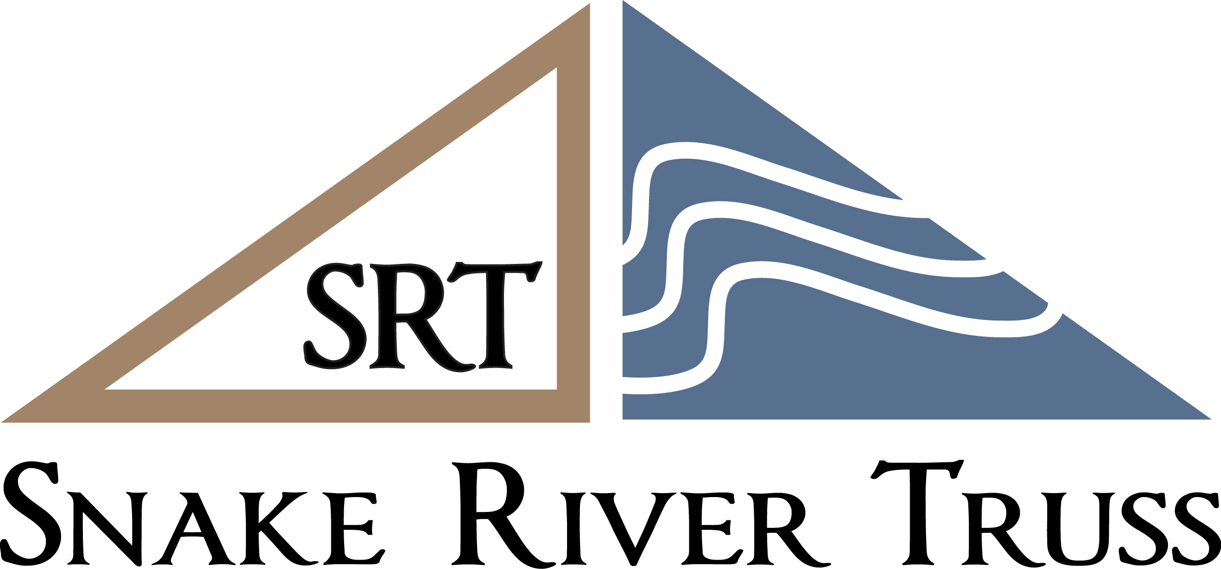
1362 Terrill Drive, Idaho Falls, ID 83401
Phone # (208) 522-8787 Fax # (208) 528-7882

CONFIDENTIAL APPLICATION FOR CREDIT
Business Name__________________________________ Address ______________________________
Owner/Officer Name ____________________________________________Phone__________________
Address_______________________________________________________SS#____________________
Owner/Officer Name ____________________________________________Phone__________________
Address_______________________________________________________SS#_____________________
Email ___________________________________________________Federal Tax ID #________________
Sales Tax Exempt? ___No __Yes Number ________________________________________________
If yes, an ST101 Tax Exemption Certificate must be completed.
Business is a ____Corporation ____Partnership ____Individual _____LLC _______Other
Years in Business ____________________Main Industry___________________________________________
Expected Monthly Purchases__________________________________________________________________
Business Property is ___Owned ____Rented Number of Years There ____________________________
Annual Sales $____________________________ Number of Employees______________________________
Current Suppliers Selling on Open Accounts:
Name City Telephone High Credit

1.________________________________________________________________________________________

2.________________________________________________________________________________________

3.________________________________________________________________________________________

Bank ____________________________________ Checking Acct #_______________________________

Bank phone # _____________________________ Savings Loan

Location__________________________________ Contact Name__________________________________

THIS INFORMATION IS GIVEN FOR THE PURPOSE OF OBTAINING CREDIT AND IS CERTIFIED TO BE CORRECT – SNAKE RIVER TRUSS IS AUTHORIZED TO VERIFY ANY AND ALL INFORMATION ON THIS APPLICATION AND TO OBTAIN CREDIT INFORMATION FROM THE SOURCES LISTED. I (WE) AGREE TO PAY A FINANCE CHARGE ON ALL PAST DUE AMOUNTS AT THE RATE OF 1 ½ % PER MONTH (18% PER ANNUM) AND TO PAY REASONABLE ATTORNEY FEES AND COLLECTION COSTS FOR ANY AMOUNT REFERRED FOR COLLECTION TO ANY AGENCY OF ATTORNEY, AND THAT ALL PURCHASES ARE DUE AND PAYABLE IN BONNEVILLE COUNTY, IDAHO.

Signature ______________________________ Printed Name ____________________________ Date ____________

“Truss Order Terms and Conditions” The undersigned (“Purchaser”) agrees that all purchases made by purchaser from Snake River Truss & Components LLC (“Seller”) are subject to the following terms and conditions. These terms and conditions supersede all other job documents.
- Purchaser shall purchase the trusses it orders from Snake River Truss & Components LLC upon manufacture.
- Snake River Truss will fabricate the trusses for Purchaser in accordance with dimensions shown on bid and/or truss engineering and layout documents unless otherwise notified by Purchaser.
- If Purchaser notifies Snake River Truss of any changes to the trusses after Snake River Truss has commenced cutting/building trusses, Purchaser shall be liable for any resulting increase in price.
- Purchaser of Metal Plate Connected Wood Trusses and Snake River Truss agree, that the ANSI/TPI Industry standard and the Standard “Commentary & Appendices” for the Trusses will be followed by all that are involved in the purchase, sale, handling, and installation of trusses purchased from Snake River Truss. **SEE “JOBSITE PACKAGE” for further information.
- Engineering or shop drawings supplied by Snake River Truss are for individual trusses and do not constitute a roof system design. This responsibility remains with the Purchaser.
- Purchaser and Snake River Truss agree that the delivery of trusses is considered a delivery method ONLY and not in any way to be considered a part of the installation of the trusses.
- Snake River Truss shall deliver the manufactured trusses at a time and place as agreed upon by the parties. Purchaser shall provide a safe and clear access to the delivery location to aid the Snake River Truss delivery person (“driver”) in unloading the trusses. Snake River Truss shall not be responsible for any additional costs incurred for other equipment necessary to install the trusses. Snake River Truss will deliver the trusses to the building site when accessible and safe and shall not be liable for any damage to sidewalks, curbs, driveways, or other improvements.
- Purchaser shall pay the cost of towing any Snake River Truss or other delivery vehicle delivering the trusses if towing becomes necessary due to delivery site conditions.
- Immediately upon delivery to the specified delivery location, all risk of loss and responsibility for the trusses shall pass to Purchaser. Purchaser shall be responsible for (i) handling, storing, and bundling the trusses, and (ii) installing, bracing, bracing connection, and connections to the supporting structure. The bracing material is not supplied unless otherwise specified. Snake River Truss shall provide Purchaser with a publication detailing suggested industry standard procedures for handling, storing, installing, and bracing trusses. Snake River Truss shall have no responsibility to inspect the trusses after installation or to verify the dimensions or adequacy of work done by other trades that may relate to the trusses.
- Use of the trusses by Purchaser constitutes an acceptance of such materials
- Purchaser agrees that whoever shall nail/bolt girder trusses together will follow the instructions in the supplied engineering for the girder truss and any minimum requirements of the building code.
- Snake River Truss may provide truss hanger hardware to purchaser, and if so, the purchaser agrees that it is the purchasers responsibility to obtain all proper design information and installation requirements for the hardware from the hardware manufacturer.
- Purchaser agrees that Snake River Truss and their representative reserve the right to conduct field inspection(s) of the trusses when there are reported discrepancies and are also allowed access for any needed repairs. Note** Purchaser agrees any repair will be completed during the construction phase. Any repair needed after closing in of the trusses is the responsibility of the purchaser.
- If Snake River Truss has to hold an order for 30 days or more beyond the agreed upon delivery date for any reason not caused by Snake River Truss, the Purchaser shall pay the purchase price.
- Any claims Purchaser may have for defective trusses must be made within five days of delivery. If no claim is made within such five-day period, the trusses delivered will be deemed to be accepted by Purchaser.
- Purchaser and Snake River Truss agree that Snake River Truss will retain a copy of the entire project file, to include the agreement/contract, engineering, invoice, and other proper documents for a period of no less than two years.
- Snake River Truss expressly disclaims all warranties, either expressed or implied, of merchantability or fitness for any particular purpose concerning the fitness of the materials delivered other than that the trusses will be manufactured in accordance with the terms of the purchase order and as otherwise expressly provided herein. Wood products have naturally occurring latent defects that are not ascertainable by inspection, including insects and similar natural conditions. Any items not manufactured by Snake River Truss are warranted only as warranted by the manufacturers of such items, otherwise all such items are sold on an “AS IS” basis. If any defect in materials delivered is discovered within one (1) year after delivery, Snake River Truss will replace such defective materials. Snake River Truss shall have no liability for any defects discovered more than one (1) year after delivery. Snake River Truss assumes no liability, whether in contract, tort, negligence, under any warranty, or otherwise, for any special, indirect, incidental, consequential or other damages. Any recommendation or advice made by a Snake River Truss representative is strictly for purposes of assisting the Purchaser and in no way constitutes a representation or warranty.
- The provisions of this Agreement shall not be modified or waived without the express written consent of Snake River Truss. All discussions or documents regarding trusses on future orders are merged into and superseded by the terms of this Agreement. Additional terms shall become part of this agreement only with the express written consent of Snake River Truss.
WARNING: Truss top chords, bottom chords, and webs must be laterally and diagonally braced during erection to prevent personal injury or property damage. See bracing instructions delivered with trusses. DO NOT CUT TRUSSES. Snake River Truss is not responsible for any alteration to the trusses made at the job site without specific written approval from Snake River Truss.

I have read and agree to the above Truss Order Terms and Conditions:

Owner/Officer Signature _____________________________________________ Date________________

Printed Name ____________________________________Title______________________________________

Personal Guaranty of Company Account:

FOR CONSIDERATION GIVEN I (WE) HERBY PERSONALLY GUARANTY ANY AND ALL INDEBTEDNESS OF THE COMPANY TO SNAKE RIVER TRUSS & COMPONENTS AND BIND OURSELVES TO PAY ON DEMAND ANY SUM BECOMING PAST DUE. THIS GUARANTEE IS CONTINUING AND IRREVOCABLE AND THE BASIS IS PART, FOR GRANTING CREDIT.

- All accounts are due and payable in full by the 10th of the month following purchases.

- If payment is not received by the 27th of the month following the due date, a finance charge of 1 ½ % of the unpaid balance will be assessed to your account.

- In the event the account is placed with an attorney or other agency for collection, or suit is brought on same, or the same is collected through judicial proceeding whatsoever, purchaser shall pay all reasonable attorney’s fees and court costs incurred by seller.

- The terms and provisions of this credit application agreement shall be binding and fully enforceable against the purchaser, and personally against its owners, officer, shareholders, agents, servants and employees, and that all of said persons and entities are personally, jointly and severally liable on account of the terms and provisions hereof, and agree fully to be bound to each and every one of the terms and provisions of this credit application agreement.

Guarantor Signature ___________________________ Printed _______________________Date__________

Guarantor Signature ___________________________ Printed _______________________Date__________

